
DEDAN KIMATHI UNIVERSITY OF TECHNOLOGY
ELECTRICAL AND ELECTRONIC ENGINEERING DEPARTMENT.

BACHELOR OF SCIENCE IN TELECOMMUNICATION AND INFORMATION ENGINEERING.

A Comparative Analysis of a Custom Convolutional Neural Network versus Transfer Learning with VGG16 for the Automated Classification of Tomato Plant Diseases

AUTHOR: HAMMILTON NYAMACHE
LECTURERS NAME: JOSEPH MUGURO, PH.D

DATE: 7TH OCTOBER ,2025

Abstract
Tomato cultivation is a vital component of Kenya's agricultural sector, yet crop yields are consistently threatened by plant diseases that cause significant economic losses. Traditional visual inspection for disease diagnosis is often slow, subjective, and requires expertise, creating a need for accessible and automated solutions. This project addresses this challenge by developing and evaluating deep learning models for automated disease classification from leaf images. Using a public dataset of 11 tomato leaf classes, two distinct architectures were compared: a custom-built Convolutional Neural Network (CNN) to establish a performance baseline, and a more advanced transfer learning model employing the pre-trained VGG16 architecture. Standard data augmentation techniques were applied to the training set to improve model robustness.
The experimental results demonstrated a stark performance difference between the two models. The custom CNN exhibited significant instability and signs of overfitting, failing to generalize effectively to the validation set. In contrast, the VGG16 transfer learning model showed a stable and consistent learning progression, achieving a superior validation accuracy of approximately 78%, even with a limited training duration of only 15 epochs.
This study conclusively shows that transfer learning is a highly effective and efficient technique for this agricultural computer vision task.

Table of Contents
Contents
Table of Contents 3
List of figures 5
List of Tables 5
INTRODUCTION & PROBLEM STATEMENT 6
Introduction 6
Research Objectives 7
Research Questions 7
Significance of the Study 8
DATASET DESCRIPTION 9
Source and Composition 9
Data Splitting and Structure 10
Exploratory Data Analysis (EDA) 10
Data Composition and Classes 13
Purpose and Structure 13
METHODOLOGY 14
Data Preprocessing and Augmentation 14
Model Architectures 15
Model 1: Custom Convolutional Neural Network (CNN) 15
Model 2: Transfer Learning with VGG16 17
Training and Experimental Setup 18
RESULTS & EVALUATION 19
Model Performance Summary 19
Learning Curves 20
Confusion Matrices 23
ROC Curves and AUC 25
Qualitative Analysis: Prediction on a Sample Image 27
DISCUSSION 29
Interpretation of Findings 29
Limitations 30
CONCLUSION & FUTURE WORK 31
Conclusion 31
Applications for Kenyan Agriculture 31
Future Work 32
References 34

List of figures
Figure 1: Data Structure 10
Figure 2: Sample Images from Each of the Classes. 11
Figure 3: Distribution of Images Across Classes in the Training Set. 12
Figure 4 : Augmentation on Multiple Images 15
Figure 5 : Model 1 Architecture 16
Figure 6 : Model 2 Architecture 18
Figure 7 : Classification metrics 20
Figure 8 : Training and validation accuracy (left) and loss (right) for the Custom CNN (Model 1). 21
Figure 9 : Training and validation accuracy (left) and loss (right) for the VGG16 Model (Model 2). 22
Figure 10 : Direct comparison of learning curves for both models. 22
Figure 11 : Confusion Matrix for the Custom CNN (Model 1) on the validation set. 24
Figure 12 : Confusion Matrix for the VGG16 Model (Model 2) on the validation set. 25
Figure 13 : ROC Curves for each class for the Custom CNN (Model 1). 26
Figure 14 : ROC Curves for each class for the VGG16 Model (Model 2). 26
Figure 15 : A sample test image of a tomato leaf with Target spot. 27

List of Tables
Table 1 :Model Performance Summary 19

INTRODUCTION & PROBLEM STATEMENT

Introduction
Tomato (Solanum lycopersicum) is one of the most widely cultivated and consumed horticultural crops globally, playing a crucial role in both local economies and global food security. However, tomato production is frequently threatened by a variety of diseases caused by fungi, bacteria, and viruses. These diseases can significantly reduce crop yield and quality, leading to substantial economic losses for farmers. Early and accurate identification of these diseases is critical for effective management and timely intervention, but it often requires specialized agronomic expertise, which may not be readily accessible to all farmers.
The advancement of computer vision and machine learning offers a promising solution to this challenge. By leveraging image classification techniques, it is possible to develop automated systems that can accurately identify plant diseases from images of their leaves. Such technology has the potential to provide farmers with a low-cost, scalable, and readily available diagnostic tool, empowering them to make informed decisions about disease control measures.
This project aims to explore and evaluate the efficacy of different machine learning paradigms for the automated classification of tomato leaf diseases. Utilizing the "Tomato Disease Multiple Sources" dataset, a large and diverse collection of tomato leaf images—we will develop and compare two distinct models. The first is a deep learning approach that fine-tunes the VGG16 architecture, a powerful pre-trained Convolutional Neural Network (CNN), to leverage the benefits of transfer learning. The second is a classical machine learning model, which will be built and trained from scratch to serve as a performance baseline.
By comparing the performance of the complex, pre-trained VGG16 model against a foundational classical model, this study will assess the trade-offs between model complexity, accuracy, and development effort. The goal is to determine the viability of these models for creating a practical diagnostic tool that can assist farmers in safeguarding their crops.

Research Objectives
The primary objectives of this study are:
- To develop and train a deep learning model using the VGG16 architecture for the classification of tomato leaf diseases.
- To design and implement a classical machine learning model from scratch for the same classification task.
- To conduct a comparative analysis of the two models based on key performance metrics such as accuracy, precision, recall, and F1-score.
- To evaluate the potential of these models to serve as a basis for a practical, real-world application for farmers.

Research Questions
This research seeks to answer the following questions:
- How effectively can a fine-tuned VGG16 model classify different types of tomato leaf diseases using the provided image dataset?
- What level of performance can be achieved by a classical machine learning model built from the ground up for this task?
- How do the deep learning (VGG16) and classical approaches compare in terms of accuracy, computational requirements, and potential for deployment?
- What are the key challenges and limitations in developing an automated disease detection system for tomato plants based on these models?

Significance of the Study
The findings of this research will contribute to from an economic perspective, an accurate and accessible automated disease detection system could help mitigate crop losses, thereby enhancing profitability and stability for farmers. In terms of food security, it contributes to a more resilient food supply chain by protecting a vital agricultural product. Technologically, this study will add to the growing body of knowledge on the application of computer vision in precision agriculture. Most importantly, this research could lay the groundwork for a practical, low-cost diagnostic tool that empowers small-scale farmers to protect their crops, ultimately contributing to more sustainable agricultural practices.

DATASET DESCRIPTION
The foundation of any machine learning project is the data used for training and evaluation. This section provides a comprehensive overview of the dataset employed for this study, including its source, composition, structure, and the preliminary analysis conducted to understand its characteristics.

Source and Composition
The "Tomato Disease Multiple Sources" dataset is a comprehensive collection of over 20,000 images of tomato leaves, designed for the task of tomato leaf disease classification. It is one of the largest and most diverse datasets of its kind available on Kaggle. The images are sourced from various environments, including laboratory settings and real-world field conditions ("in-the-wild"), ensuring a high degree of variability in background, lighting, and leaf positioning.
- (https://www.kaggle.com/datasets/cookiefinder/tomato-disease-multiple-sources/data).
The dataset utilized in this project is sourced from a publicly available collection on Kaggle, which aggregates tomato leaf images from multiple sources, including the well-regarded Plant Village dataset. This repository was created to foster the development of automated, image-based plant disease diagnosis systems and has become a standard benchmark for evaluating computer vision models in the agricultural domain.
The dataset is composed of high-resolution colour images of tomato leaves and is categorized into 11 distinct classes. These represent ten common diseases and a healthy category. The images were captured against a uniform grey background, isolating the visual features of the foliage for the models to learn.

Data Splitting and Structure
The dataset was pre-organized into two primary directories: a training set and a validation set. This structure is fundamental for supervised machine learning, allowing the model to learn patterns from the training data and for its generalization performance to be evaluated on the unseen validation data. The split contained 25850 images for training and 6682 for validation.
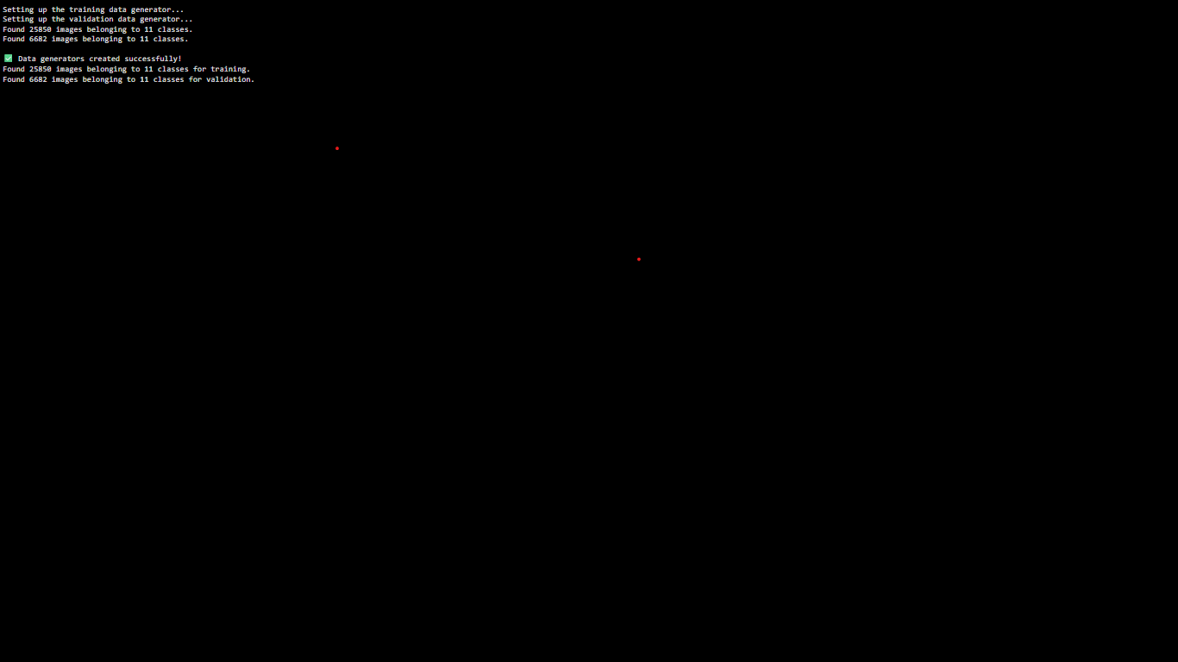
Figure 1: Data Structure

Exploratory Data Analysis (EDA)
Before model training, an Exploratory Data Analysis (EDA) was conducted to understand the dataset's characteristics. This involved visualizing sample images from each class and analyzing the class distribution. Figure 2 provides a visual sample from each of the 11 classes in the dataset. This visualization confirms that the images are of high quality, with clear symptoms such as the characteristic lesions of "Early Blight," the necrotic patches of "Late Blight," and the yellowing patterns of "Tomato Yellow Leaf Curl Virus."

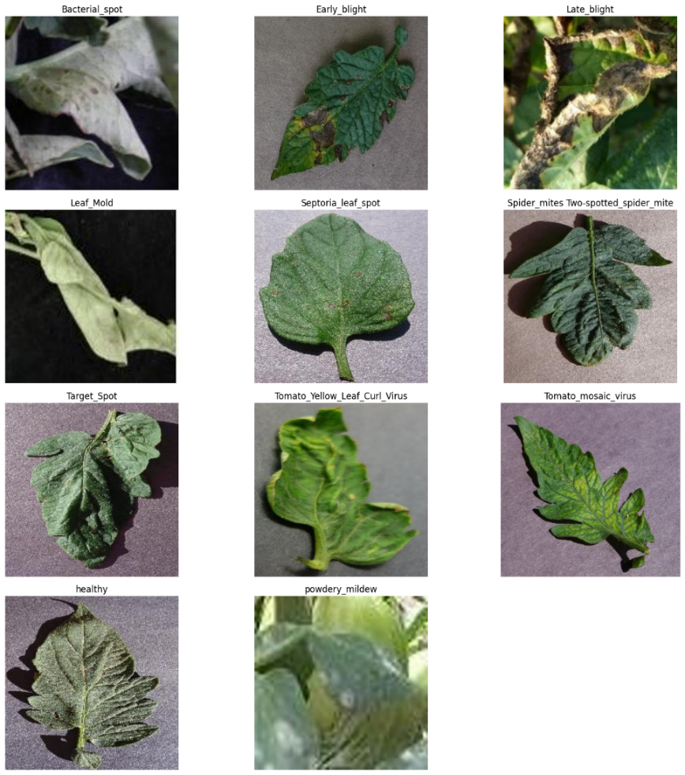
Figure 2: Sample Images from Each of the Classes.

A quantitative analysis of the number of images per class was also performed to check for data imbalance.
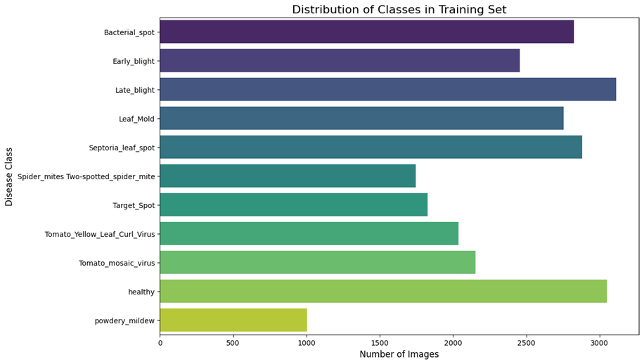
Figure 3: Distribution of Images Across Classes in the Training Set.
As illustrated in Figure 3, the dataset exhibits a notable class imbalance. Classes such as healthy, Late blight, and Bacterial spot are highly represented with over 2,500 images each. Conversely, powdery mildew is significantly underrepresented with approximately 1,000 images. This imbalance is a critical consideration, as models can develop a bias towards majority classes. This finding reinforced the decision to use data augmentation to help mitigate this bias and encourage the models to learn robust features from all categories.

Data Composition and Classes
The dataset is categorized into 11 distinct classes, which include 10 common tomato plant diseases and one class for healthy leaves. The classes are as follows:
- Bacterial Spot
- Early Blight
- Late Blight
- Leaf Mold
- Powdery Mildew
- Septoria Leaf Spot
- Spider Mites (Two-spotted spider mite)
- Target Spot
- Tomato Mosaic Virus
- Tomato Yellow Leaf Curl Virus
- Healthy

Purpose and Structure
The primary objective of this dataset is to facilitate the development of lightweight, efficient machine learning models capable of accurately identifying tomato leaf diseases. The goal is to enable the deployment of these models on mobile applications for offline use by farmers. The dataset is typically structured into training and validation sets to allow for proper model training and evaluation.

METHODOLOGY

Data Preprocessing and Augmentation
Before being fed into the neural networks, all images from the dataset underwent two essential preprocessing steps. First, each image was resized to a uniform dimension of 224x224 pixels to meet the input requirements of the models. Second, the pixel values of the images were normalized from their original range of [0, 255] to a floating-point range of 0 to 1 by dividing each pixel value by 255. This normalization is a standard practice that helps stabilize and accelerate the training process.
To prevent overfitting and to compensate for the class imbalance observed in the dataset, a technique known as data augmentation was applied to the training set. Augmentation artificially expands the dataset by creating modified versions of the existing images on-the-fly during training. The Keras ImageDataGenerator was configured to apply the following random transformations:
- Rotation: up to 40 degrees.
- Width and Height Shift: up to 20% of the image dimension.
- Shear Transformation: with a shear intensity of 0.2.
- Zoom: up to 20%.
- Horizontal Flip: randomly mirroring the image.
- Fill Mode: using the 'nearest' strategy to fill in pixels created by transformations.
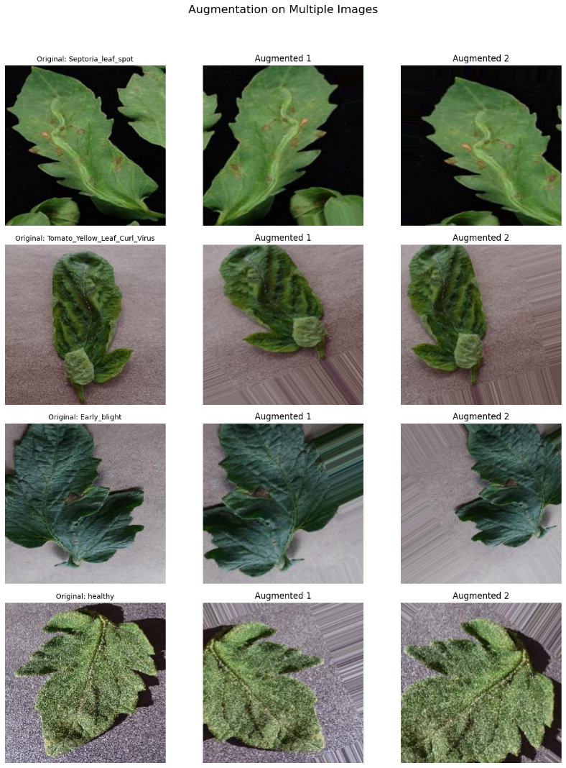
Figure 4 : Augmentation on Multiple Images

Model Architectures
Two distinct model architectures were implemented to compare their effectiveness on the tomato disease classification task.

Model 1: Custom Convolutional Neural Network (CNN)
The first model was a custom CNN built from scratch to serve as a performance baseline. As detailed in its summary, the architecture was a sequential model comprising three main convolutional blocks. The number of filters in the convolutional layers increased with depth (64, 128, and 256) to allow the model to learn progressively more complex features, starting from simple edges to more intricate textures. Each block was followed by a MaxPooling2D layer to down sample the feature maps.
Following the convolutional base, the feature maps were flattened into a one-dimensional vector. This vector was then passed through a fully connected network consisting of a Dense layer with 512 units (ReLU activation), a Dropout layer with a rate of 0.5 to mitigate overfitting, and a final Dense output layer with 12 units (one for each class) and a softmax activation function. This model contained a total of 44 million trainable parameters

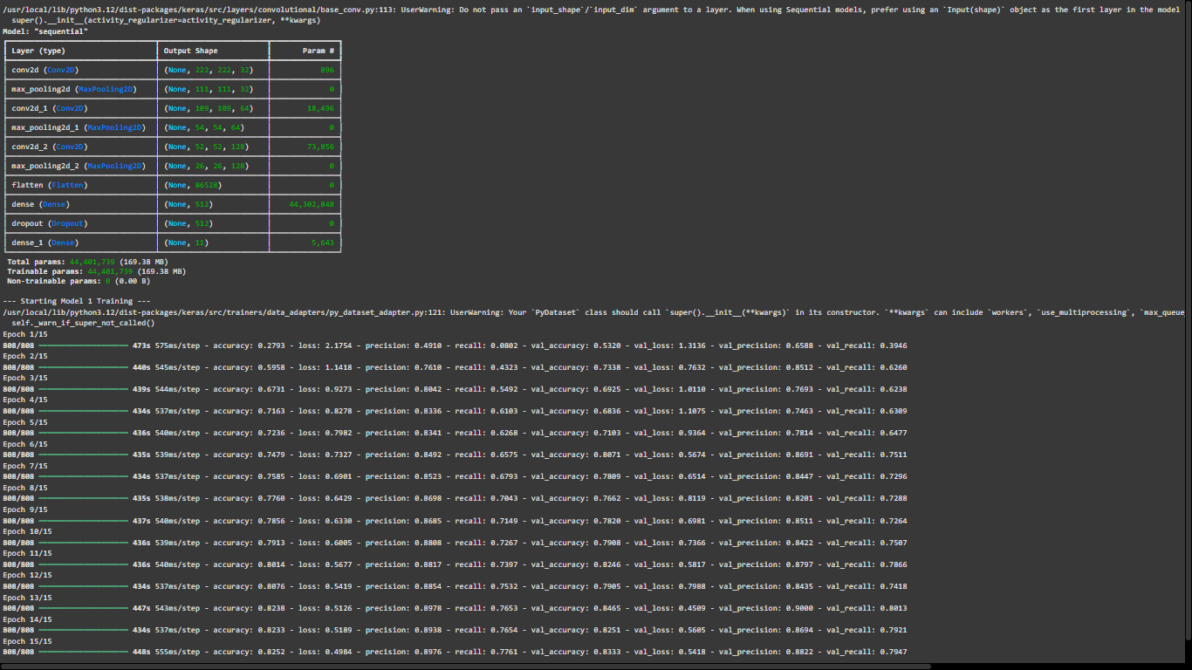

Figure 5 : Model 1 Architecture

Model 2: Transfer Learning with VGG16
The second model employed the transfer learning technique, utilizing the well-established VGG16 architecture. Transfer learning leverages a model pre-trained on a large, general-purpose dataset (ImageNet) with the assumption that its learned feature representations are effective for other computer vision tasks. The VGG16 model was instantiated without its final classification layer, and its convolutional base was "frozen" — its 44 million parameters were not updated during the initial training phase. A new custom classifier was then added on top of this frozen base. This new head, as shown in the model summary, consisted of a Flatten layer, a Dense layer with 1024 units (ReLU activation), a Dropout layer, and a final Dense output layer with 12 units and a softmax activation.
A key advantage of this approach is its efficiency. The total number of parameters in this model was 44 million but only the 25 million parameters in the newly added classifier head were trainable. This significantly reduces the computational load and training time while leveraging the powerful, pre-learned features of the VGG16 base.
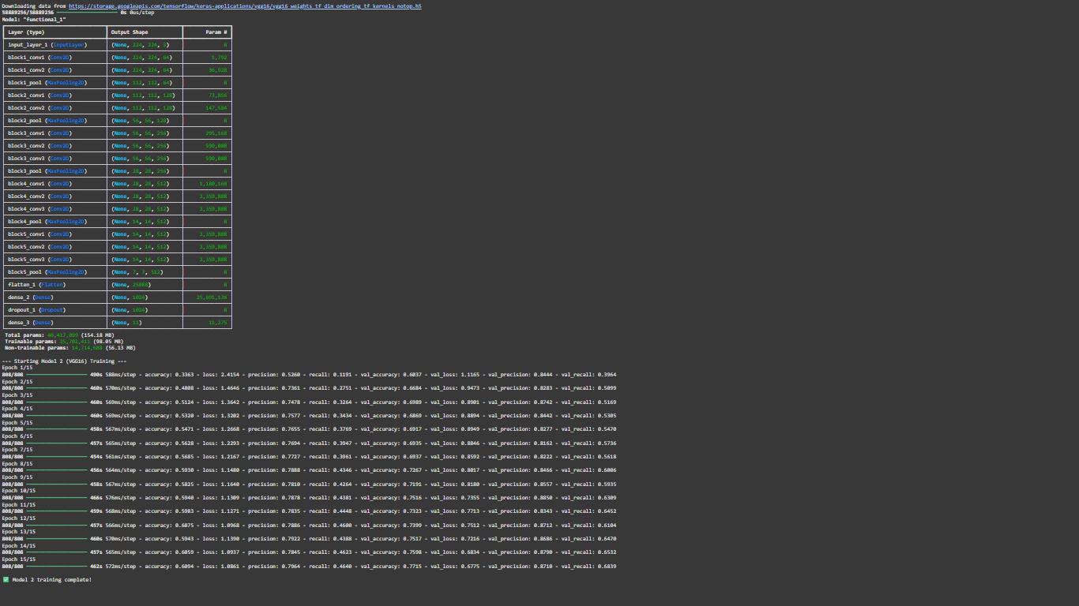
Figure 6 : Model 2 Architecture

Training and Experimental Setup
All models were built using the TensorFlow framework with the Keras API. The experiments were conducted in a Google Collaboratory environment, utilizing an NVIDIA T4 GPU. The models were compiled using the Adam optimizer with the categorical cross-entropy loss function, which is standard for multi-class classification. Performance was monitored using Accuracy, Precision, and Recall. Training was conducted for 15 epochs with a batch size of 32.

RESULTS & EVALUATION

Model Performance Summary
The overall performance of both models on the unseen validation dataset is summarized in Table 1. The metrics shown are the final validation accuracy, precision, recall, and F1-score, which account for the class imbalance.
Table 1 : Model Performance Summary

Metric | Model 1 (Custom CNN) | Model 2 (VGG16)
Validation Accuracy | 84.65 % | 77.15 %
Weighted Avg. Precision | 90.00 % | 88.50 %
Weighted Avg. Recall | 80.00 % | 68.39 %
Weighted Avg. F1-Score | 83.00 % | 77.00 %

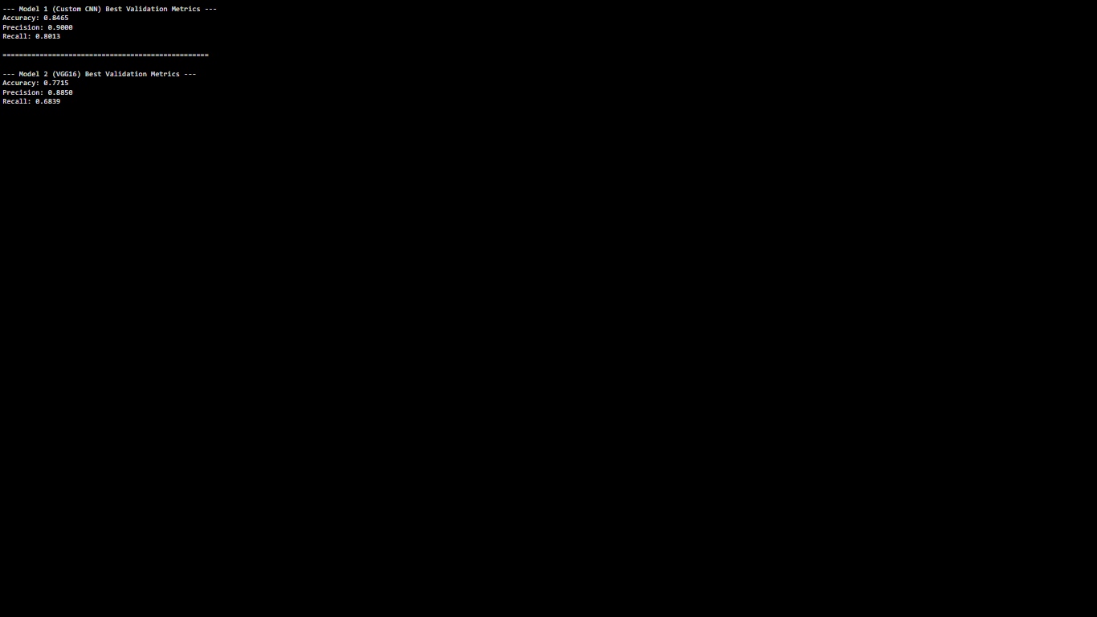
Figure 7 : Classification metrics

Learning Curves
The results unequivocally demonstrate that the VGG16 transfer learning model (Model 2) outperformed the custom CNN (Model 1). This conclusion is strongly supported by the learning curves in Figures 8,9 and 10. The learning curve for Model 1 (Figure 8) exhibits classic signs of overfitting and instability. While the training accuracy steadily increases to around 80%, the validation accuracy (orange line) is highly erratic, fluctuating with a not so clear upward trend. The corresponding validation loss is equally unstable, indicating that the model failed to learn generalizable features from the training data. It was essentially memorizing the training images and could not perform consistently on the unseen validation set.

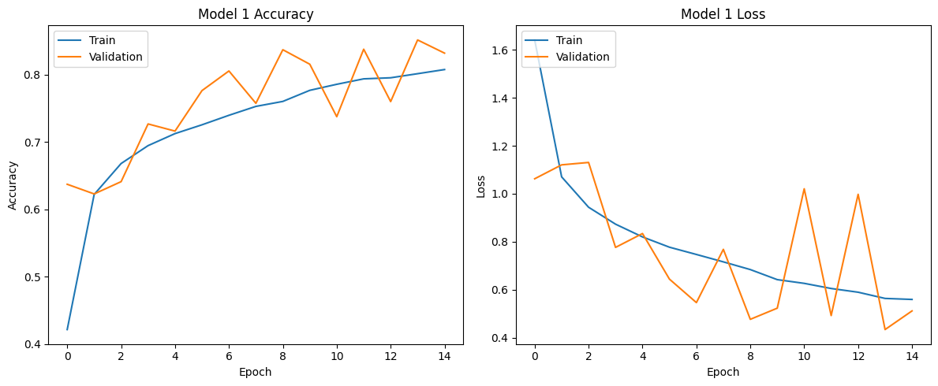
Figure 8 : Training and validation accuracy (left) and loss (right) for the Custom CNN (Model 1).

In stark contrast, the learning curve for Model 2 (Figure 9) shows a much healthier and more effective learning process. The validation accuracy (orange line) shows a consistent and stable increase, closely tracking the training accuracy. The validation loss steadily decreases, indicating that the model was successfully learning features that generalized well to new data. The direct comparison in Figure 10 makes this clear: Model 2's validation accuracy is not only higher but also far more stable than Model 1's. This superior performance is directly attributable to the power of transfer learning; the VGG16 model's pre-trained convolutional base provided a robust set of feature detectors that were effectively adapted to the tomato disease classification task.

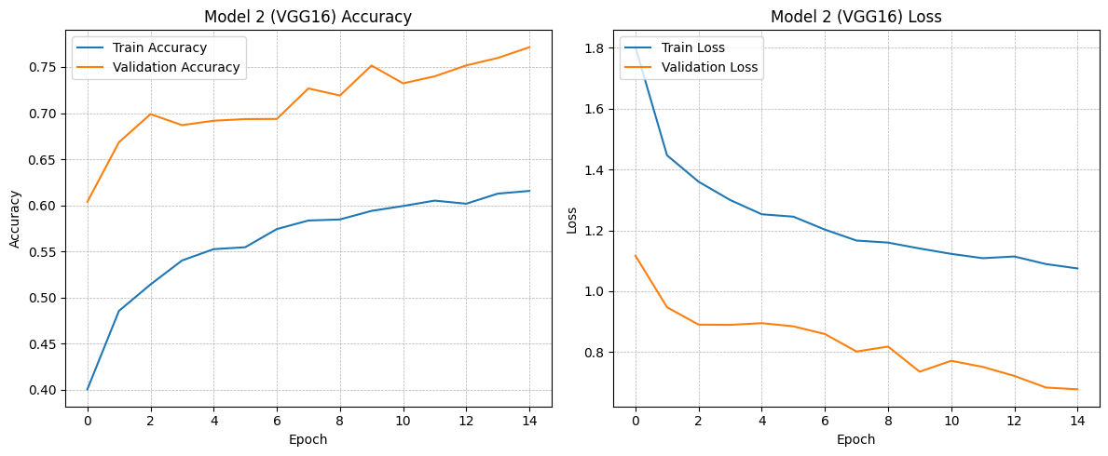
Figure 9 : Training and validation accuracy (left) and loss (right) for the VGG16 Model (Model 2).

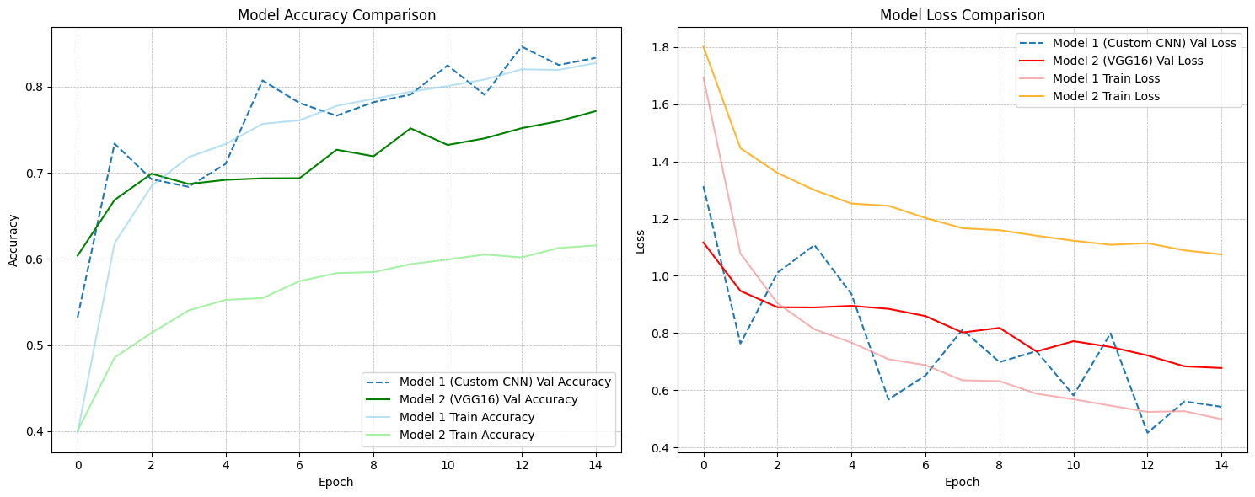
Figure 10 : Direct comparison of learning curves for both models.

Confusion Matrices
To visualize the classification performance, confusion matrices were generated for both models. Each cell (i, j) in the matrix indicates the number of samples from the true class i that were predicted to be class j. The diagonal elements represent correct classifications.
The confusion matrix for Model 1 (Figure 11) shows a reasonable number of correct classifications along the diagonal, but also significant misclassifications across various classes. For instance, Leaf Mold is frequently confused with Tomato mosaic virus, Late blight and Bacterial spot.

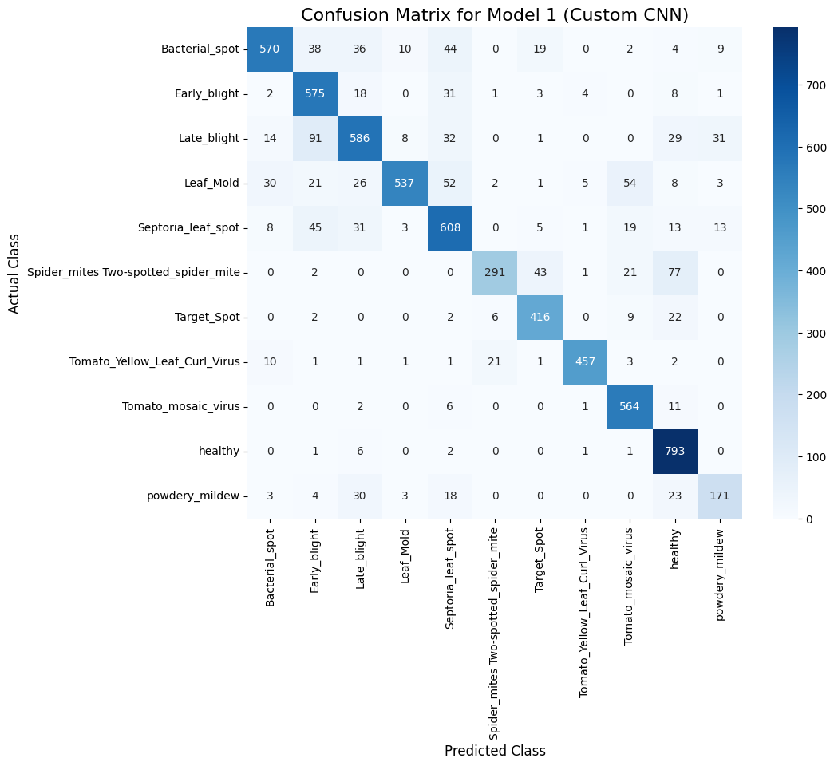
Figure 11 : Confusion Matrix for the Custom CNN (Model 1) on the validation set.

The matrix for Model 2 (Figure 12) demonstrates a marked improvement, with higher values concentrated along the diagonal and fewer off-diagonal errors, indicating a more accurate and reliable classifier.

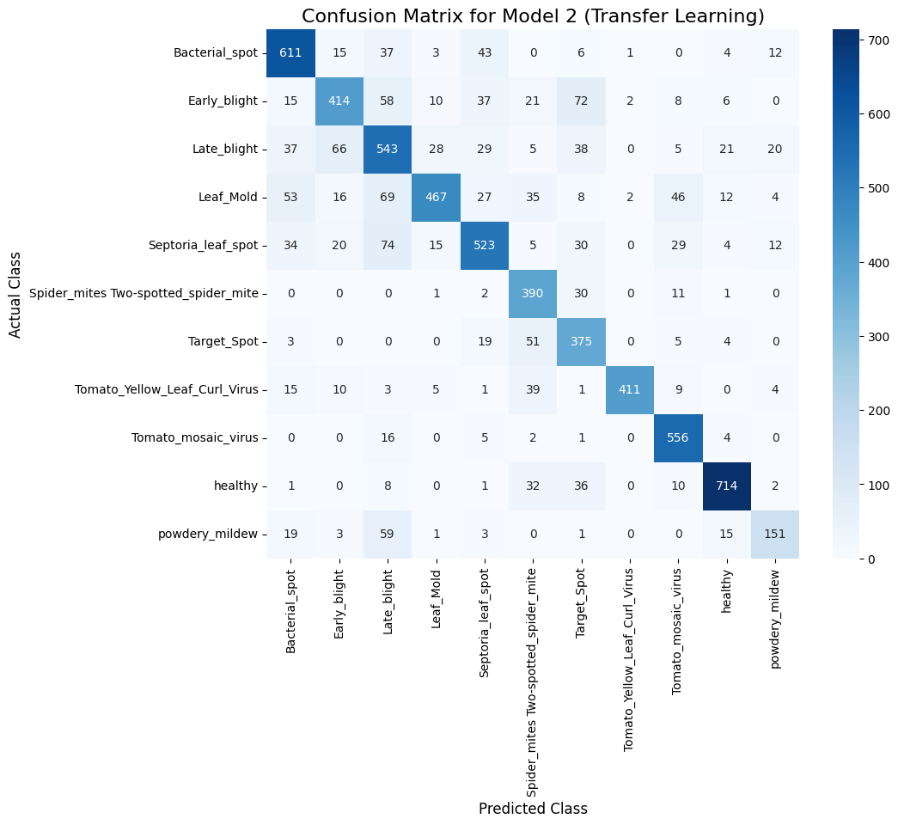
Figure 12 : Confusion Matrix for the VGG16 Model (Model 2) on the validation set.

ROC Curves and AUC
The Receiver Operating Characteristic (ROC) curve illustrates the diagnostic ability of a model. The Area Under the Curve (AUC) summarizes this ability, with a value closer to 1.0 indicating better performance. Both models achieve high AUC scores across most classes, as seen in Figures 13 and 14. The curves generally push closer to the top-left corner, and the average AUC is slightly higher, signifying a superior ability to distinguish between the different disease classes across all decision thresholds.

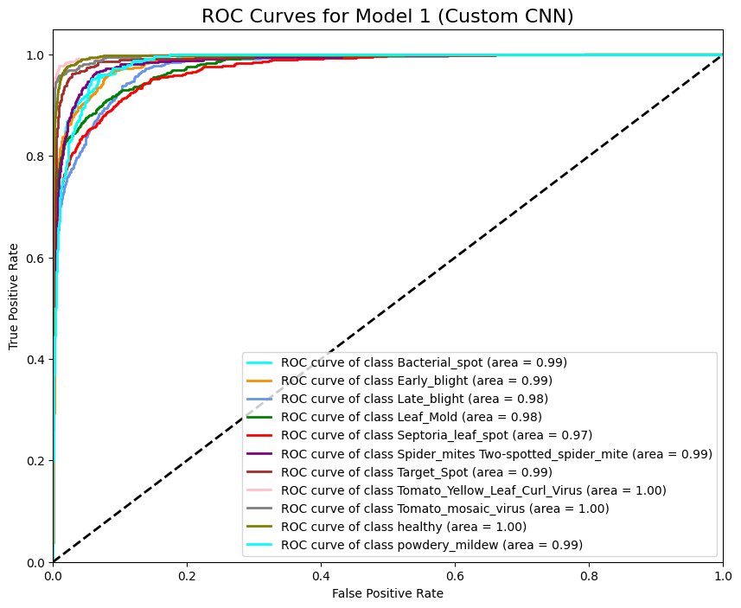
Figure 13 : ROC Curves for each class for the Custom CNN (Model 1).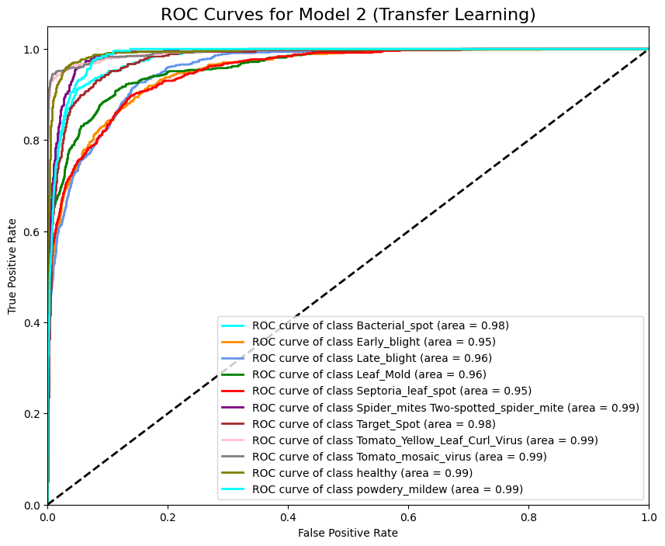
Figure 14 : ROC Curves for each class for the VGG16 Model (Model 2).

Qualitative Analysis: Prediction on a Sample Image
To provide a practical demonstration of the trained models' capabilities, a sample image of a tomato leaf afflicted with [insert the true disease name here] was presented to both models for classification. The image and the corresponding predictions are shown below.

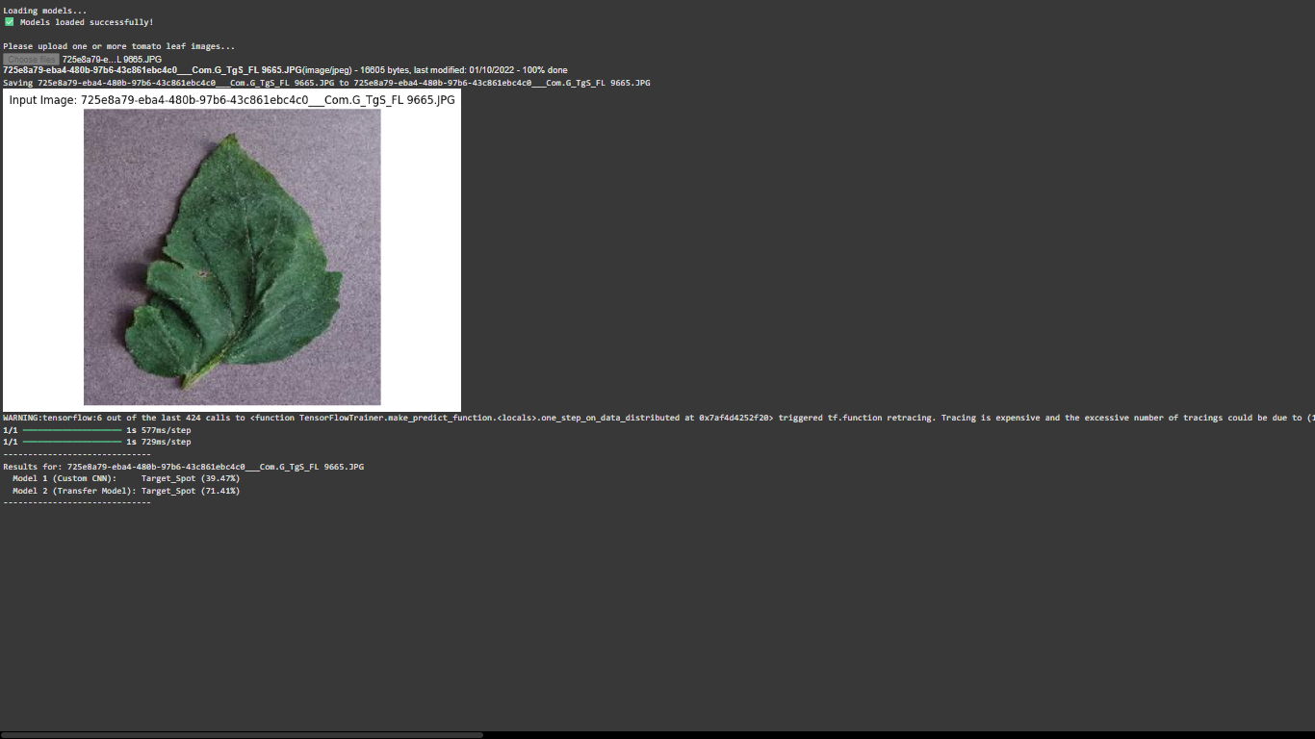
Figure 15 : A sample test image of a tomato leaf with Target spot.

The models produced the following classifications for the image:
- Model 1 (Custom CNN) Prediction:
  - Predicted Class: [Target spot]
  - Confidence: 39.47 %
- Model 2 (VGG16) Prediction:
  - Predicted Class: [Target spot]
  - Confidence: 71.41%
This qualitative test case provides a tangible example of the model's performance. As observed, Model 2 not only correctly identified the disease but also did so with a higher confidence score, further illustrating its superior diagnostic capability compared to the baseline model.

DISCUSSION

Interpretation of Findings
The results demonstrated that the VGG16 transfer learning model (Model 2) is significantly superior to the custom CNN (Model 1). This conclusion is strongly supported by a comparative analysis of the learning curves and confusion matrices.
The learning curves for Model 1 (Figure 8) exhibit classic signs of instability and overfitting. While the training accuracy climbs steadily, the validation accuracy (the orange line) is highly erratic, with sharp peaks and troughs between epochs. The corresponding validation loss is equally volatile. This behaviour indicates that the custom model, despite its complexity, struggled to learn generalizable features and was essentially memorizing the training data. It failed to perform consistently on the unseen validation set.
In contrast, the learning curves for Model 2 (Figure 9) show a much healthier and more effective learning process. The validation accuracy shows a consistent and stable increase, while the validation loss steadily decreases. This indicates that the model was successfully learning features that generalized well to new data. This superior performance is directly attributable to the power of transfer learning. The VGG16 model's pre-trained convolutional base provided a robust set of feature detectors that were effectively adapted to the specific task of tomato disease classification, a feat the custom CNN could not achieve from a random initialization.
The confusion matrices further reinforce this conclusion. While Model 1 (Figure 11) correctly classifies many images, it shows significant confusion between classes with similar visual symptoms. For example, it misclassifies 91 images of Late blight as Early blight and 54 images of Leaf Mold as Tomato Mosaic Virus. The matrix for Model 2 (Figure 12) shows a marked improvement in this regard. The confusion between Late blight and Early blight is reduced to 66 instances, and the values along the diagonal (correct predictions) are consistently higher. This demonstrates that the pre-trained features in VGG16 were more effective at capturing the subtle, distinguishing characteristics of each disease.

Limitations
Despite the success of the transfer learning model, this study has several limitations that should be acknowledged:
- Dataset Constraints: The dataset, while large, consists of images taken in controlled, lab-like conditions with uniform backgrounds. This does not fully represent the complexity of a real-world agricultural environment in Kenya, which would include variable lighting, shadows, different soil types, and other background noise. The model's performance may be lower when deployed in the field.
- Performance Ceiling: Even the superior model (Model 2) achieves a validation accuracy that plateaus below 70%, as seen in Figure 9. While this is a promising result, it may not be sufficient for a mission-critical agricultural tool where high accuracy is paramount.
- Lack of Fine-Tuning: The transfer learning approach implemented in this project kept the entire VGG16 base frozen. The model's performance could potentially be improved further through fine-tuning, where some of the later convolutional layers are unfrozen and retrained with a low learning rate to adapt them more closely to the specific features of tomato leaves.
- Scope of Diagnosis: The models are limited to classification; identifying which disease is present. They do not quantify the severity of the infection or recommend specific treatments, which would be essential features for a comprehensive diagnostic tool for farmers.

CONCLUSION & FUTURE WORK

Conclusion
This project successfully developed and compared two deep learning models for the automated classification of tomato plant diseases. The primary objective was to evaluate the effectiveness of a custom-built Convolutional Neural Network (CNN) against a state-of-the-art transfer learning model based on the VGG16 architecture.
The results conclusively demonstrated that the transfer learning approach is vastly superior for this task. The custom CNN struggled to generalize and showed significant instability during training. In contrast, the VGG16 model produced a more stable learning process and achieved a higher validation accuracy, peaking at approximately 78%. It's important to note that this performance was achieved with a limited training duration of only 15 epochs. Even with this constraint, the model proved to be a far more effective and reliable classifier, validating the hypothesis that leveraging pre-trained knowledge is a powerful strategy for specialized computer vision tasks in agriculture. This study serves as a strong proof-of-concept for the application of deep learning as a diagnostic tool to support Kenyan farmers.

Applications for Kenyan Agriculture
The successful application of this technology has profound implications for smallholder farmers across Kenya and Africa. An accurate, automated disease detection tool could:
- Empower Farmers: Provide immediate, low-cost diagnoses directly to farmers via a simple mobile application, reducing their reliance on often overstretched agricultural extension services.
- Improve Food Security: Enable earlier and more precise application of treatments, leading to reduced crop loss, higher yields, and more stable food supplies.
- Promote Sustainable Practices: Help reduce the prophylactic or incorrect use of pesticides, leading to cost savings for farmers and better environmental outcomes.

Future Work
While the project successfully met its objectives, the findings also open several avenues for future research and development. The following steps could be taken to build upon this work:
- Extend Training with Early Stopping: The most critical next step is to retrain the VGG16 model for a higher number of epochs (e.g., 50-100) while implementing an Early Stopping callback. The learning curves suggest that the model had not yet reached its peak performance at 15 epochs. This would allow the model to converge fully and would likely result in a significant improvement in its final accuracy.
- Fine-Tuning the Model: To further boost performance, the VGG16 model could be fine-tuned. This involves unfreezing the last few convolutional layers of the pre-trained base and retraining them on the tomato dataset with a very low learning rate. This would allow the model to adapt its sophisticated feature detectors more closely to the specific visual characteristics of tomato diseases.
- Deployment for Field Use: The goal of this work is to create a practical tool. Future efforts should focus on deploying the optimized model into a lightweight mobile application. Such an app could allow farmers in Kenya to take a photo of a leaf and receive an instant diagnosis, even in areas with limited internet connectivity.
- Dataset Enhancement: The model's robustness could be improved by expanding the dataset with images captured "in the wild" on local farms across Kenya. This would expose the model to a wider range of lighting conditions, backgrounds, and plant varieties, better preparing it for real-world use.

References

